**UI**

User interface elements usually fall into one of the following four categories:

Input Controls

Navigation Components

Informational Components

Containers

Accordion

Bento Menu

Breadcrumb

Button

Card

Carousel

Checkbox

Comment

Döner Menu

Dropdown

Feed

Form

Hamburger Menu

Icon

Input Field

Kebab Menu

Loader

Meatballs Menu

Modal

Notification

Pagination

Picker

Progress Bar

Radio Buttons

Search Field

Sidebar

Slider Controls

Tag

Tab Bar

Tooltip

Toggle

**https://careerfoundry.com/en/blog/ui-design/ui-element-glossary/** => 2020

**Terminology**

Globals

Element

Collection

Views

Modules

Behaviors

**Project Terminology**

Component

Definition

Ui

**Definition Terminology**

Component

Definition

Types

Variations

Content

States

Behaviors

**General Terms**

Namespace

Gulp

NPM

Node JS

[**https://semantic-ui.com/introduction/glossary.html**](https://semantic-ui.com/introduction/glossary.html) **=> 2016**

**Top Android UI Controls that you must know about!**

TextView

EditText

Button

ImageButton

ToggleButton

RadioButton

RadioGroup

CheckBox

AutoCompleteTextView

ProgressBar

Spinner

TimePicker

DatePicker

SeekBar

AlertDialog

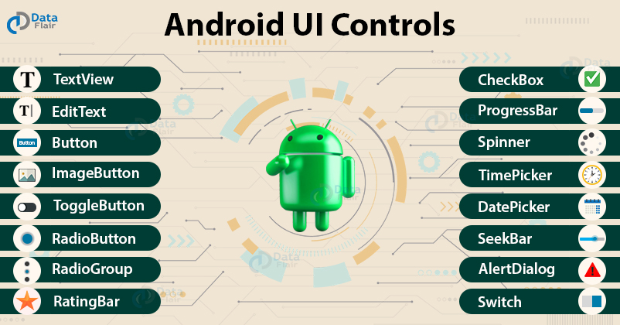

TextView

### EditText

### Button

### ImageButton

ToggleButton

RadioButton

RadioGroup

CheckBox

ProgressBar

Spinner

TimePicker

DatePicker

SeekBar

RatingBar

AlertDialog

Switch

AutoCompleteTextView

[**https://data-flair.training/blogs/android-ui-controls/**](https://data-flair.training/blogs/android-ui-controls/) **=> 2020**

Cheat sheets: UI terms

Style (its about: **Color, Grid, Iconology, and Typography**)

Structure (its about: **Surface, Sheets, Navigation, Tab, Drawer, Backdrop)**

Communication (its about: **Banner, Snackbar, Alert, Dialog** )

Inputs (its about: **Search, Input Text Field, Chips**)

Control (its about: **Floating Action Button, Speed Dial, Picker, Radio Buttons, Checkboxes, etc** )

Landing (its about: **Onboarding, Empty State, UI placeholder, Shimmer, Empty State** )

[**https://uxdesign.cc/cheat-sheets-ui-terms-cadf9dc49689**](https://uxdesign.cc/cheat-sheets-ui-terms-cadf9dc49689) **=> 2021**

**iOS User Interface**

**macOS**

## macOS Design Themes

Flexible

Expansive

Capab

Focusedle

Icons and Images

App Accent Colors

Windows and Views

Sidebars

Toolbars and Title Bars

Table Views

Sheets

Alerts

Menus

Controls

Typogra

Widgetsphy

**iOS**

**Clarity**

**Deference**

**Depth**

**Design Principles**

**Aesthetic Integrity**

**Consistency**

**Direct Manipulation**

**Feedback**

**Metaphors**

**User Control**

[Bars](https://developer.apple.com/design/human-interface-guidelines/ios/bars/)

[Views](https://developer.apple.com/design/human-interface-guidelines/ios/views/)

[Controls](https://developer.apple.com/design/human-interface-guidelines/ios/controls/)

## Launching

**Provide a launch screen**

**Launch in the appropriate orientation**

**Avoid asking for setup information up front.**

**Rebooting**

**rate**

**restarts**

**licens**

**watchOS**

[complication](https://developer.apple.com/design/human-interface-guidelines/watchos/overview/complications/)

[notifications](https://developer.apple.com/design/human-interface-guidelines/watchos/overview/notifications/)

[Siri](https://developer.apple.com/design/human-interface-guidelines/watchos/overview/siri/)

[app experience](https://developer.apple.com/design/human-interface-guidelines/watchos/overview/apps/)

### Design Fundamentals

**Task**

**Interactions**

**Glanceable**

**Paire**

**Range**

**Include**

**launch screen**

**logo**

**font**

**tvOS**

## tvOS Design Themes

### Connected

Clear

Immersive

[**https://developer.apple.com/design/human-interface-guidelines/**](https://developer.apple.com/design/human-interface-guidelines/) **=> 2021**

**UI Fabric | Microsoft**

## **Basic Inputs**

[Button](https://developer.microsoft.com/en-us/fluentui#/controls/web/button)

[Checkbox](https://developer.microsoft.com/en-us/fluentui#/controls/web/checkbox)

[ChoiceGroup](https://developer.microsoft.com/en-us/fluentui#/controls/web/choicegroup)

[ComboBox](https://developer.microsoft.com/en-us/fluentui#/controls/web/combobox)

[Dropdown](https://developer.microsoft.com/en-us/fluentui#/controls/web/dropdown)

[Label](https://developer.microsoft.com/en-us/fluentui#/controls/web/label)

[Link](https://developer.microsoft.com/en-us/fluentui#/controls/web/link)

[Rating](https://developer.microsoft.com/en-us/fluentui#/controls/web/rating)

[SearchBox](https://developer.microsoft.com/en-us/fluentui#/controls/web/searchbox)

[Slider](https://developer.microsoft.com/en-us/fluentui#/controls/web/slider)

[SpinButton](https://developer.microsoft.com/en-us/fluentui#/controls/web/spinbutton)

[TextField](https://developer.microsoft.com/en-us/fluentui#/controls/web/textfield)

[Toggle](https://developer.microsoft.com/en-us/fluentui#/controls/web/toggle)

## **Galleries & Pickers**

[Calendar](https://developer.microsoft.com/en-us/fluentui#/controls/web/calendar)

[ColorPicker](https://developer.microsoft.com/en-us/fluentui#/controls/web/colorpicker)

[DatePicker](https://developer.microsoft.com/en-us/fluentui#/controls/web/datepicker)

[PeoplePicker](https://developer.microsoft.com/en-us/fluentui#/controls/web/peoplepicker)

[Pickers](https://developer.microsoft.com/en-us/fluentui#/controls/web/pickers)

[SwatchColorPicker](https://developer.microsoft.com/en-us/fluentui#/controls/web/swatchcolorpicker)

**Notification & Engagement**

ProgressIndicator

Shimmer

Spinner

**Commands, Menus & Navs**

[Breadcrumb](https://developer.microsoft.com/en-us/fluentui#/controls/web/breadcrumb)

[CommandBar](https://developer.microsoft.com/en-us/fluentui#/controls/web/commandbar)

[ContextualMenu](https://developer.microsoft.com/en-us/fluentui#/controls/web/contextualmenu)

[Nav](https://developer.microsoft.com/en-us/fluentui#/controls/web/nav)

[OverflowSet](https://developer.microsoft.com/en-us/fluentui#/controls/web/overflowset)

[Pivot](https://developer.microsoft.com/en-us/fluentui#/controls/web/pivot)

## **Items & Lists**

ActivityItem

DetailsList

DocumentCard

Facepile

GroupedList

HoverCard

Basic List

Persona

## **Surfaces**

[Callout](https://developer.microsoft.com/en-us/fluentui#/controls/web/callout)

[Dialog](https://developer.microsoft.com/en-us/fluentui#/controls/web/dialog)

[Modal](https://developer.microsoft.com/en-us/fluentui#/controls/web/modal)

[Panel](https://developer.microsoft.com/en-us/fluentui#/controls/web/panel)

[ScrollablePane](https://developer.microsoft.com/en-us/fluentui#/controls/web/scrollablepane)

[Tooltip](https://developer.microsoft.com/en-us/fluentui#/controls/web/tooltip)

## **Utilities**

Announced

FocusTrapZone

FocusZone

Icon

Image

Keytips

Layer

MarqueeSelection

Overlay

ResizeGroup

Selection

Separator

Stack

Text

ThemeProvider

Themes

**References**

AutoScroll

Autofill

BaseComponent

Check

DateTimeUtilities

DelayedRender

EventGroup

FabricPerformance

GlobalSettings

IAccessiblePopupProps

IAnimationStyles

IBaseProps

IChangeDescription

IChangeEventCallback

IComponentAs

IComponentAsProps

IDisposable

IDragDropHelper

IEffects

IFontFace

IFontStyles

IPalette

IRawFontStyle

IRawStyle

IRawStyleBase

IRectangle

IRenderComponent

IScheme

ISelectableDroppableTextProps

ISemanticColors

ISemanticTextColors

ISize

IStyle

IStyleBase

IStyleBaseArray

IStyleFunction

IStyleFunctionOrObject

ITheme

Point

Rectangle

Selection

TagPicker

Theme

ThemeProvider

VerticalDivider

WeeklyDayPicker

[**https://developer.microsoft.com/en-us/fabric#/controls/web**](https://developer.microsoft.com/en-us/fabric#/controls/web)

* **2021**

**Material UI| React**

**Single-page Application**

## ES6, ES2015, ES2016, etc

## Compilers

## Bundlers

Package Managers

CDN

JSX

Elements

Components

Props

props.children

state

Lifecycle Methods

Controlled vs. Uncontrolled Components

Keys

Refs

Events

Reconciliation

[**https://reactjs.org/docs/glossary.html**](https://reactjs.org/docs/glossary.html) **=> 2021**